Exercises — Peak Cooling Load Concept and Design Basis
Table of Contents

1.2 Peak Cooling Load — Concept and Design Basis

1.2.1 Why Equipment Must Be Sized for Peak Conditions
An air conditioning system is a steady-state machine: at any instant, it must remove heat from the conditioned space at a rate equal to — or greater than — the rate at which heat is entering. If heat enters faster than the system can remove it, room temperature rises above setpoint.
The rate at which heat enters a conditioned space is not constant. It varies continuously with outdoor temperature, solar position, occupancy level, lighting schedules, and equipment usage. The peak cooling load is defined as the maximum rate of heat gain the conditioned space experiences during its normal operating period.
Source: Praphan, Ch. 1, p. 1
Design principle:
$$Q_{equipment}≥Q_{peak}$$
If this condition is satisfied, the system handles all other operating hours automatically, since every non-peak hour has a lower heat gain by definition.
Figure 1.5 illustrates the variation of total cooling load over a typical day in an office building, showing how individual heat sources combine to produce a single daily peak.
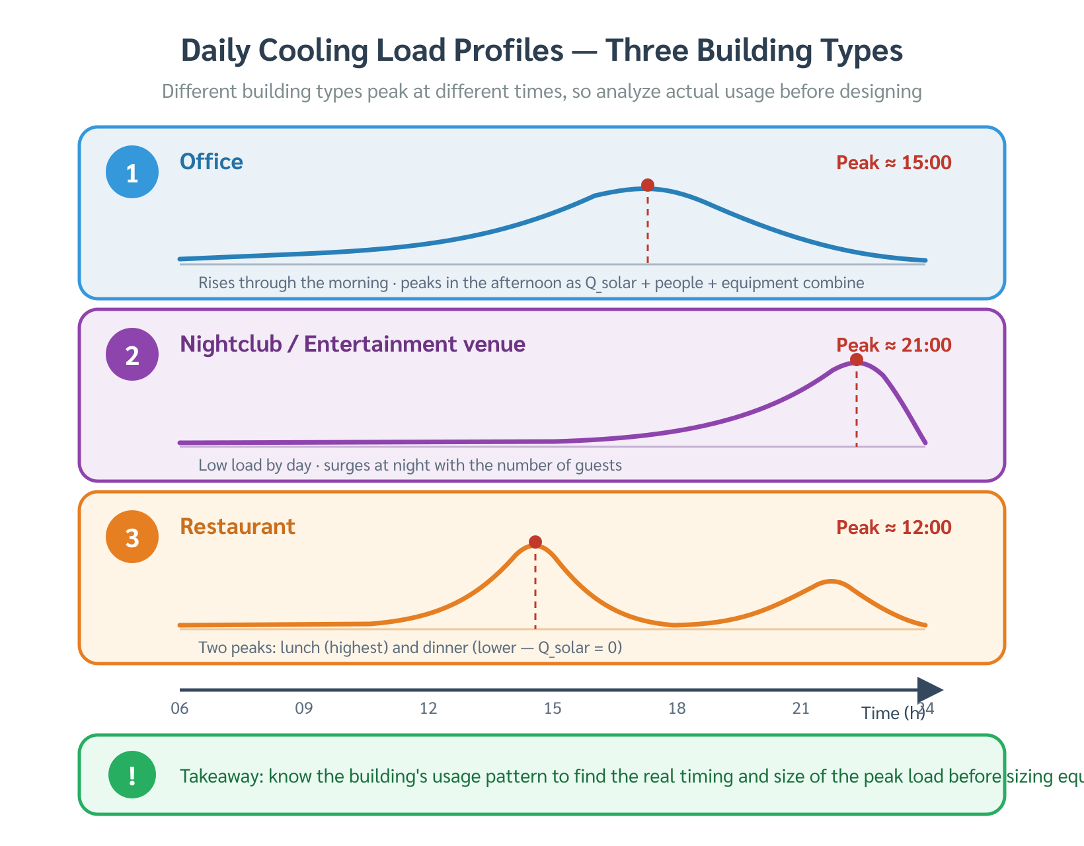
Figure 1.5 — Daily Cooling Load Profile — Office Building
Figure 1.5 — Daily Cooling Load Profile — Office Building
Source: Praphan, Ch. 1, p. 1

1.2.2 Sources of Cooling Load
The total cooling load on a space is the sum of heat gains from all sources acting simultaneously. These sources fall into three main categories:

A. External Heat Gains (Envelope-Driven)
Solar heat gain through glazing: Sunlight passing through windows delivers shortwave radiation directly into the space. The rate depends on window area, glazing type (solar heat gain coefficient, SHGC), and the solar angle — which varies by time of day, date, and building orientation.
Conduction through opaque envelope: Heat conducts inward through walls, roof, and floor whenever the outdoor surface temperature exceeds the indoor setpoint. The rate follows:
$$Q_{cond}=U×A×ΔT$$
where: - $Q_{cond}$ = conductive heat gain (Btu/h or W) - $U$ = overall heat transfer coefficient (Btu/h·ft²·°F or W/m²·K) - $A$ = surface area (ft² or m²) - $ΔT$ = temperature difference across the assembly (°F or °C)
Envelope thermal lag: Massive elements (concrete walls, roof slabs) absorb solar energy during the day and re-release it inward hours later. This time delay — typically 2–6 hours for a 200 mm concrete wall — shifts peak conduction load into the afternoon even after solar radiation has passed its noon maximum.

B. Internal Heat Gains
Occupants: Each person releases both sensible heat (raising air temperature) and latent heat (moisture from respiration and perspiration). The split depends on activity level:
Activity Level | Sensible (Btu/h) | Latent (Btu/h) | Total (Btu/h) | Total (W)
Seated, light office work | 250 | 200 | 450 | 132
Standing, light work | 275 | 275 | 550 | 161
Walking, moderate activity | 305 | 395 | 700 | 205
Heavy physical work | 580 | 870 | 1,450 | 425
Source: ASHRAE Fundamentals Handbook, Table 1
Lighting: All electrical energy consumed by luminaires ultimately becomes heat in the conditioned space. For fluorescent and LED fixtures:
$$Q_{light}=W_{installed}×CLF$$
where CLF (Cooling Load Factor) accounts for the fraction of heat that has already entered the space versus heat stored in the fixture and structure.
Typical lighting densities: offices 10–15 W/m² (1.0–1.4 W/ft²), retail 20–30 W/m² (1.9–2.8 W/ft²).
Electrical equipment: Computers, printers, kitchen equipment, and process machinery all convert electrical power to heat. A standard workstation (computer + monitor) contributes approximately 175–250 W of heat.

C. Ventilation and Infiltration
Fresh outdoor air supplied for ventilation must be cooled (and dehumidified) to room conditions. This represents both a sensible and a latent load:
$$Q_{s,vent}=1.08×\text{CFM}×ΔT \text{(IP: Btu/h, }ΔT\text{ in °F)}$$
$$Q_{s,vent}=1.23×{\dot{V}}_{L/s}×ΔT \text{(SI: W, }ΔT\text{ in °C)}$$
$$Q_{l,vent}=0.68×\text{CFM}×ΔW \text{(IP: Btu/h, }ΔW\text{ in gr/lb)}$$
$$Q_{l,vent}=3,010×{\dot{V}}_{L/s}×ΔW_{kg/kg} \text{(SI: W)}$$
where $ΔW$ is the humidity ratio difference between outdoor and indoor air.

1.2.3 Time of Peak Load — Building-Type Dependence
The hour at which all heat sources combine to produce their maximum simultaneous total is building-specific. It is determined by:
- The orientation of major glazed surfaces (which wall faces west?)
- The thermal mass of the envelope (how long is the lag?)
- The occupancy and equipment schedule
- The ratio of solar gain to internal gain

Office Buildings (08:00–18:00 operation, heavy west glazing)
Peak: 15:00–16:00 (3:00–4:00 PM)
By mid-afternoon, three effects peak together: 1. West façade solar gain — the sun moves to the west after noon; west-facing glass receives maximum direct radiation at approximately 15:00 2. Envelope thermal lag — heat absorbed by the roof and east/south walls since morning has conducted through and is now entering the space 3. Accumulated internal gains — occupants, lighting, and equipment have been running for 7+ hours; heat stored in furniture, floor slabs, and partitions during the morning is now being released
Source: Praphan, Ch. 1, p. 1
Figure 1.6 shows the heat gain breakdown for an office building at 15:00, illustrating the relative contributions of each source.
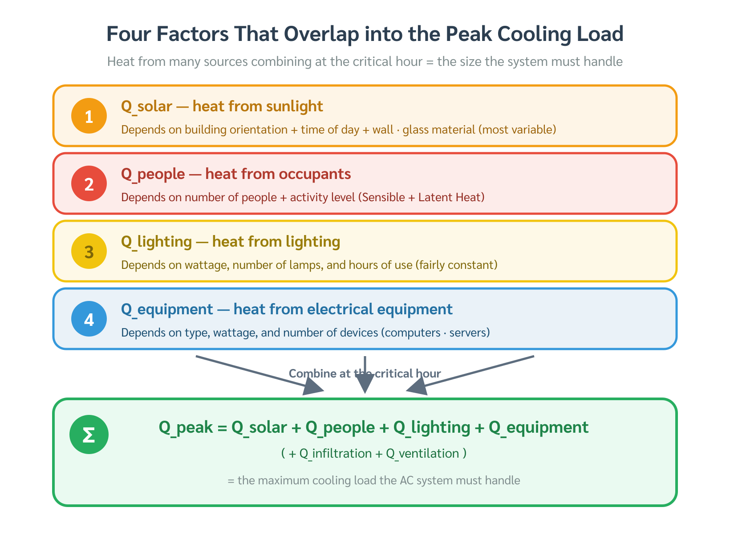
Figure 1.6 — Heat Gain Breakdown — Office Building at 15:00
Figure 1.6 — Heat Gain Breakdown — Office Building at 15:00
Source: Praphan, Ch. 1, p. 1

Nightclubs and Entertainment Venues (20:00–02:00 operation)
Peak: 21:00–22:00 (9:00–10:00 PM)
At this hour: 1. Solar gain = zero — the venue operates entirely after sunset 2. Occupant density is maximum — a full crowd of dancers or patrons, each releasing 700–1,450 Btu/h (205–425 W) depending on activity 3. Lighting load is maximum — entertainment lighting typically 40–80 W/m², far higher than office applications 4. Latent load dominates — perspiration from high-activity occupants means latent heat gain greatly exceeds sensible heat gain
Source: Praphan, Ch. 1, p. 2
Figure 1.7 compares the dominant heat sources at peak for an office versus a nightclub, illustrating why peak time shifts by 6+ hours between the two building types.
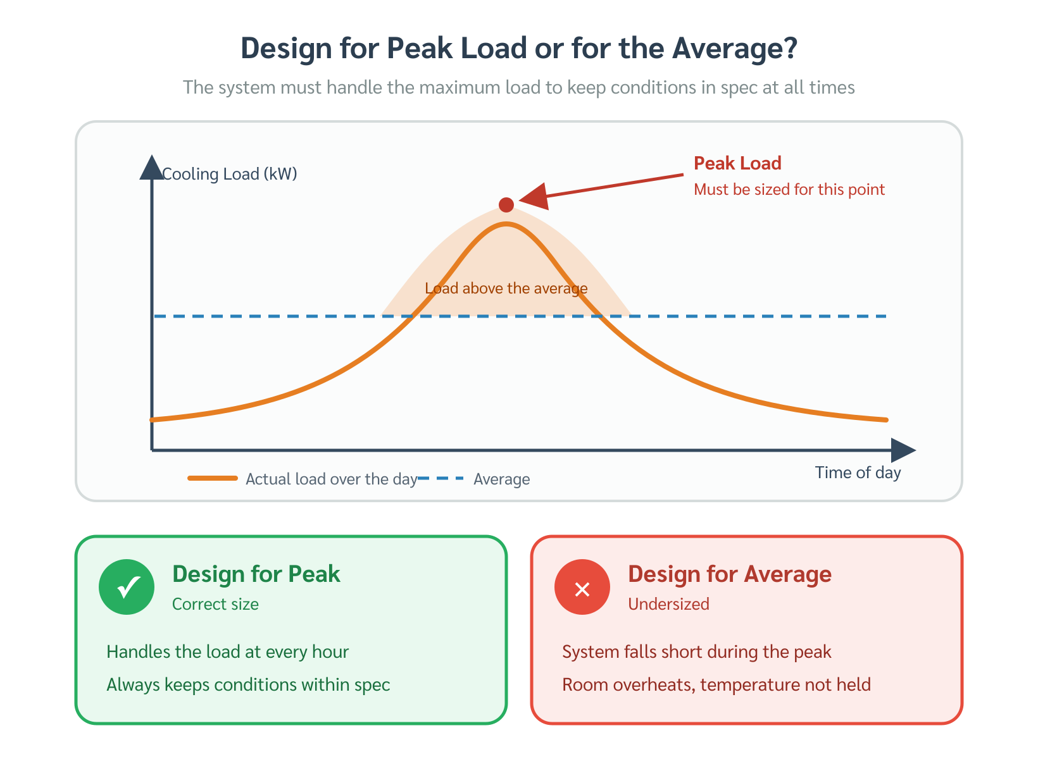
Figure 1.7 — Peak Load Composition: Office (15:00) vs. Nightclub (21:00)
Figure 1.7 — Peak Load Composition: Office (15:00) vs. Nightclub (21:00)
Source: Praphan, Ch. 1, p. 2

1.2.4 Consequences of Incorrect Sizing

Undersized System
If $Q_{equipment}<Q_{peak}$: - The system runs continuously at 100% capacity but cannot remove heat fast enough during peak hours - Room temperature rises above setpoint → occupant discomfort or process failure - The system may still maintain setpoint during off-peak hours, masking the problem until a hot summer day reveals it

Oversized System
If $Q_{equipment}≫Q_{peak}$ (significantly oversized):
- Short-cycling — the system satisfies the thermostat quickly and shuts off, then restarts frequently. Compressors are most vulnerable to damage at startup; frequent cycling accelerates wear.
- Poor dehumidification — moisture removal requires the cooling coil to operate long enough for condensation to form and drain. Short cycles mean the coil surface never gets cold enough long enough to remove adequate moisture. The space feels cool but humid (“clammy”).
- Energy waste — oversized equipment draws more power than necessary and operates at part-load conditions where efficiency (COP) is typically lower than at design point.
- Higher capital cost — larger equipment, larger electrical supply, larger piping and ductwork.
Source: Praphan, Ch. 1, p. 1

1.2.5 The Peak Load Calculation Procedure
Since peak load cannot be measured before the building is occupied, it must be calculated. The calculation follows a structured procedure:
Step 1 — Building survey: Collect geometry, orientation, envelope construction, occupancy, lighting, and equipment data (Chapter 3).
Step 2 — Identify design conditions: Select outdoor design temperature and humidity from weather data for the project location (Chapter 4).
Step 3 — Calculate each heat gain component at the assumed peak hour for each hour of the design day (Chapters 4–7).
Step 4 — Sum all components to find total cooling load at each hour.
Step 5 — Identify the hour of maximum total load — this is the design peak.
Step 6 — Apply safety factor and select equipment.
$$Q_{design}=Q_{peak,calc}×(1+SF) \text{where }SF=0.05\text{–}0.15$$

Summary — Topic 1.2
- Peak cooling load = the maximum simultaneous heat gain rate; equipment must be sized to meet it
- Heat gains come from three categories: external (solar, envelope conduction), internal (occupants, lighting, equipment), and ventilation
- Peak time is building-specific: offices peak at 15:00–16:00 (west solar + lag + internal); nightclubs peak at 21:00–22:00 (occupants + lighting, latent-dominant)
- Undersized systems fail to maintain setpoint at peak; oversized systems short-cycle, dehumidify poorly, and waste energy
- Correct sizing requires a full load calculation — not rules of thumb

Reference: Praphan, Air Conditioning Engineering, Ch. 1, pp. 1–2; ASHRAE Fundamentals Handbook Status: draft — English version, written fresh from source

Worked Examples — Topic 1.2: Peak Cooling Load

Example 1.2.1 — Office Building: Identifying the Hour of Peak Load
Problem: A seven-story office building in Chiang Mai has a south-facing and west-facing glazed curtain wall. The building operates from 08:00 to 18:00. An engineer is asked to determine which hour should be used as the design peak for sizing the central chilled-water system. Explain the reasoning.
Given: - Orientation: south and west glazing (significant exposure) - Occupancy: 08:00–18:00 (office schedule) - Location: Chiang Mai, Thailand (tropical climate, no winter heating needed) - Internal gains: lighting 12 W/m², equipment 15 W/m², occupancy 0.1 person/m²
Analysis — Step by Step:
Step 1 — Solar heat gain through west glazing: Solar altitude and azimuth data for Chiang Mai show that west-facing glass receives maximum direct irradiance between 14:00 and 16:00 (solar time), when the sun is in the western quadrant. This is the dominant variable-load component.
Step 2 — Envelope thermal lag: The roof and south wall (concrete, 200 mm) absorb solar energy during the morning. With a thermal time constant of approximately 4–6 hours for this construction, heat that was absorbed at the peak solar noon (12:00) arrives at the interior surface around 16:00–18:00.
Step 3 — Internal gains: Occupants, lighting, and equipment have been operating continuously since 08:00. By 15:00, seven hours of accumulated heat stored in furniture, slabs, and partitions begins releasing back into the space. Internal gains are essentially constant throughout the day but their net effect on room temperature grows as the day progresses.
Step 4 — Simultaneous peak: All three effects peak simultaneously at 15:00–16:00: - West solar gain: maximum - Envelope lag: releasing morning-absorbed heat - Internal gains: fully accumulated
Answer: The design hour is 15:00 (3:00 PM). The HVAC system must be sized to remove the total heat gain at this hour. All other operating hours will have lower total loads, so a system that satisfies 15:00 will automatically handle the rest of the day.
Source: Praphan, Ch. 1, p. 1

Example 1.2.2 — Nightclub vs. Office: Why Peak Time Differs by 6 Hours
Problem: A developer is converting the ground floor of an office building into a nightclub, keeping the upper floors as offices. Explain why the nightclub and office floors require separate peak-load analyses at different hours, and what the dominant heat sources are in each case.
Given:
Parameter | Office (Floors 2–7) | Nightclub (Floor 1)
Operating hours | 08:00–18:00 | 20:00–02:00
Occupant density | 0.1 person/m² | 0.5 person/m² (full crowd)
Activity level | Seated, office work | Dancing, high activity
Lighting | 12 W/m² | 60 W/m² (entertainment)
Solar exposure | Yes (daytime) | None (nighttime)
Analysis:
Office floors — Peak at 15:00:
$$Q_{total, 15:00}=Q_{solar}+Q_{envelope}+Q_{internal}$$
At 15:00, solar gain through west glass and envelope thermal lag combine with full internal gains. Heat gain breakdown (approximate): - Solar (west glazing): ~40% of total load - Occupants + lighting + equipment: ~50% - Envelope conduction: ~10%
Nightclub — Peak at 21:00–22:00:
At 21:00, the sun has set. Solar gain = 0. The building envelope, now cooler than during the day, contributes very little conductive gain. The load is driven entirely by internal sources:
$$Q_{total, 21:00}=Q_{occupants}+Q_{lighting}+Q_{envelope, small}$$
Each high-activity occupant (dancing) releases approximately: - Sensible heat: 580 Btu/h (170 W) - Latent heat (perspiration): 870 Btu/h (255 W) - Total: 1,450 Btu/h (425 W) per person
At 0.5 person/m² in a 400 m² floor: - Number of occupants: 200 persons - Total occupant heat gain: 200 × 1,450 = 290,000 Btu/h (85 kW) - Lighting: 60 W/m² × 400 m² = 24,000 W (82,000 Btu/h) - Latent fraction: ~60% of total (high perspiration rate)
Answer: The office peaks at 15:00 (solar + internal combined). The nightclub peaks at 21:00–22:00 (occupants + entertainment lighting only, zero solar). Using the same design hour for both floors would result in a severely undersized nightclub system and unnecessary over-capacity for the office at night.
Source: Praphan, Ch. 1, pp. 1–2

Example 1.2.3 — Consequences of Oversizing: Short-Cycling and Humidity Failure
Problem: A 400 m² server support office in Bangkok has a calculated peak cooling load of 36,000 Btu/h (3 tons, 10.6 kW). The contractor installs a 60,000 Btu/h (5-ton) split-type unit instead, arguing that “bigger is always safer.” Six months later, the client complains that the office “feels cold but sticky.” Explain the engineering cause and quantify the problem.
Given: - Design peak load: 36,000 Btu/h (3 tons) - Installed capacity: 60,000 Btu/h (5 tons) - Oversizing ratio: 60,000 / 36,000 = 1.67× (67% oversized) - Typical operating load (non-peak hours): ~24,000 Btu/h (2 tons) - Minimum run time needed for effective dehumidification: 15 minutes continuous
Step 1 — Calculate run fraction at typical load:
$$\text{Run Fraction}=\frac{Q_{load}}{Q_{capacity}}=\frac{24,000}{60,000}=0.40$$
The unit runs only 40% of the time — cycling on for approximately 6 minutes, then off for 9 minutes.
Step 2 — Dehumidification failure: Moisture removal requires the cooling coil surface to drop below the dew point of the room air and remain there long enough for condensation to form and drain. With a 6-minute on-cycle: - Minutes 0–2: coil cools down to near dew point → no condensation yet - Minutes 2–6: coil is cold enough → condensation begins - Compressor cycles off → coil warms → condensation re-evaporates back into the room
Net moisture removed per cycle ≈ near zero. The system removes sensible heat (room feels cool) but fails to remove latent heat (humidity remains high).
Step 3 — Result: - Room temperature: ≈ 24°C ✓ (meets setpoint) - Relative humidity: 70–80% ✗ (design target: 50–55%) - Perception: “cold and sticky” — exactly the client’s complaint
Step 4 — Correct approach: A properly sized 3-ton unit runs continuously at peak and at 70–80% capacity during off-peak hours, maintaining coil temperature below the dew point for 20–30 minutes per cycle — sufficient for full dehumidification.
Answer: The “cold but sticky” complaint is a classic symptom of an oversized system. The engineering cause is short-cycling: the unit satisfies the thermostat too quickly to complete the dehumidification process. Correct sizing — matching equipment capacity to peak load with only a 5–10% safety margin — prevents this problem.
Source: Praphan, Ch. 1, p. 1; ASHRAE Fundamentals Handbook

Reference: Praphan, Air Conditioning Engineering, Ch. 1, pp. 1–2 Status: draft — English version, written fresh from source

Exercises — Topic 1.2: Peak Cooling Load
Difficulty: ★ Easy · ★★ Moderate · ★★★ Challenging

Exercise 1 ★
A shopping mall in Bangkok operates from 10:00 to 22:00. The building has large east-facing and west-facing glazing on both sides.
(a) At which hour would you expect the peak cooling load to occur? Give two reasons.
(b) If the mall closes at 22:00, does the HVAC engineer need to consider heat gain after closing time when sizing the system? Explain.
Answer
(a) Peak is most likely at 15:00–16:00. - Reason 1: West-facing glass receives maximum direct solar irradiance in the mid-afternoon (sun in western quadrant after noon). - Reason 2: Thermal mass of the roof and east wall has been absorbing solar heat since morning; with a 3–5 hour lag, this heat enters the interior around 15:00–17:00. - Internal gains (shoppers, lighting, food courts) are also at their highest during peak shopping hours in the afternoon.
(b) No — the system is sized for the maximum simultaneous heat gain during operating hours. After 22:00 when the mall closes, internal gains drop sharply (people leave, lights dim). Even if some envelope thermal lag continues, the total load is far below the 15:00 peak. The system sized for the operating-hour peak automatically handles post-closing conditions.

Exercise 2 ★
An engineer states: “For any building, the peak cooling load always occurs between 14:00 and 16:00.”
Is this statement correct? Explain, and give one counterexample.
Answer
Incorrect. The hour of peak cooling load depends on building type, operating schedule, and the dominant heat source — not on a fixed time of day.
Counterexample — Nightclub or entertainment venue: A nightclub opens at 20:00 and reaches peak occupancy at 21:00–22:00. At this hour: - Solar gain = 0 (sun has set) - Occupant density is maximum (0.3–0.6 person/m², high-activity dancing) - Entertainment lighting is at full intensity (50–80 W/m²)
Peak occurs at 21:00–22:00 — approximately 6 hours later than an office building.
Other examples: hospital operating theatres (variable, depends on surgery schedule), 24-hour data centres (continuous load, peak determined by outdoor conditions, not solar angle).

Exercise 3 ★
Convert the following cooling capacities. Show all steps.
(a) 48,000 Btu/h → tons of refrigeration (TR) (b) 5 TR → kW (c) 21 kW → Btu/h
Conversion factors: 1 TR = 12,000 Btu/h = 3.517 kW
Answer
(a)
$$\text{TR}=\frac{48,000\text{ Btu/h}}{12,000\text{ Btu/h per TR}}=4\text{ TR}$$
(b)
$$\text{kW}=5\text{ TR}×3.517\text{ kW/TR}=17.6\text{ kW}$$
(c)
$$\text{Btu/h}=21\text{ kW}×\frac{12,000}{3.517}=21×3,412=71,652\text{ Btu/h}≈71,600\text{ Btu/h}$$
(alternatively: 21 kW ÷ 3.517 kW/TR = 5.97 TR × 12,000 = 71,640 Btu/h)

Exercise 4 ★★
A 200 m² conference room in an office building has the following heat gain data at 15:00 on the design day:
Source | Heat Gain
Solar (south + west glass) | 18,000 Btu/h
Occupants (40 persons, seated) | 18,000 Btu/h
Lighting (12 W/m²) | 8,190 Btu/h
Equipment | 3,410 Btu/h
Envelope conduction | 4,100 Btu/h
(a) Calculate the total cooling load in Btu/h, TR, and kW.
(b) What percentage of the total load is solar gain?
(c) If the engineer applies a 10% safety factor, what equipment capacity (in TR) should be selected?
Answer
(a)
$$Q_{total}=18,000+18,000+8,190+3,410+4,100=51,700\text{ Btu/h}$$
$$=\frac{51,700}{12,000}=4.31\text{ TR}$$
$$=4.31×3.517=15.1\text{ kW}$$
(b)
$$\text{Solar fraction}=\frac{18,000}{51,700}×100=34.8\%$$
(c)
$$Q_{design}=51,700×1.10=56,870\text{ Btu/h}=\frac{56,870}{12,000}=4.74\text{ TR}$$
Select the next standard size: 5 TR unit.

Exercise 5 ★★
A textile factory must maintain 75°F (24°C) dry-bulb and 65% RH to prevent yarn breakage. The factory operates 06:00–22:00 (16 hours/day).
(a) Is this a Comfort AC or Process AC application? Justify your answer.
(b) The production manager argues that the thermostat can be raised to 79°F (26°C) during the afternoon to save energy. As the HVAC engineer, how do you respond?
(c) If the factory has no windows (no solar gain) and 200 workers on the production floor at all times, at what hour do you expect peak load? What is the dominant heat source?
Answer
(a) Process AC. The design conditions (75°F, 65% RH) are set by the material requirement (yarn moisture content and strength) — not by human comfort preference. Human comfort is a secondary benefit, not the primary design driver. The consequences of exceeding the setpoint are production losses and product defects, not just discomfort.
(b) Raising temperature to 79°F (26°C) is not acceptable for this application. Higher temperature increases yarn brittleness and breakage rate, directly increasing material waste and downtime. The 75°F setpoint is a process requirement with zero tolerance for deviation during production. Energy savings must be achieved through other means (efficient chillers, heat recovery, night setback during non-production hours).
(c) With no windows, solar gain = 0 at all hours. The load is driven by: - Internal gains: 200 workers (process AC: moderate-to-heavy activity ≈ 1,000 Btu/h per person), lighting, and machinery — all constant throughout the shift. - Outdoor air infiltration and ventilation: varies with outdoor conditions, peaking when outdoor temperature is highest.
Peak load occurs at approximately 13:00–15:00 when outdoor ambient temperature is at its daily maximum (increasing ventilation load and envelope conduction). Dominant source: occupants + machinery + peak outdoor temperature.

Exercise 6 ★★★
A building survey reveals the following about a proposed hotel in Phuket: - 120 guest rooms, each ~30 m² - 1 ballroom: 600 m², designed for 500 guests at banquet events - Pool deck (unconditioned): south-facing, 200 m²
The hotel operator asks whether the ballroom or the guest room block will determine the size of the central chiller plant.
(a) Estimate the peak cooling load for the guest room block (Btu/h and TR). Use a rule-of-thumb of 400 Btu/h per m² for hotel guest rooms in tropical climates.
(b) Estimate the peak cooling load for the ballroom at full banquet occupancy. Use: occupant gain = 800 Btu/h per person (mixed activity), lighting = 25 W/m² (8.53 Btu/h per W), no solar gain (interior ballroom).
(c) Which space governs chiller sizing? What does this tell the engineer about where to focus detailed load calculations?
Answer
(a) Guest room block:
$$Q_{rooms}=120\text{ rooms}×30{\text{ m}}^{2}/\text{room}×400{\text{ Btu/h·m}}^{2}$$
$$=3,600{\text{ m}}^{2}×400=1,440,000\text{ Btu/h}=120\text{ TR}$$
(b) Ballroom at full banquet: - Occupant gain: $500×800=400,000$ Btu/h - Lighting: $600{\text{ m}}^{2}×25{\text{ W/m}}^{2}×3.412=51,180$ Btu/h - Total: $400,000+51,180=451,180\text{ Btu/h}=37.6\text{ TR}$
(c) The guest room block governs at 120 TR — approximately 3× the ballroom load (37.6 TR).
This tells the engineer to focus detailed load calculations on the guest room envelope (roof, walls, glazing per room orientation) since errors there have 3× the impact on final chiller size. The ballroom, while a high-density space, represents only ~24% of the total plant load and should be checked for diversified demand (banquets are not held 24/7 — the chiller plant may not see guest-room peak and banquet peak simultaneously).
Note: A more rigorous analysis would apply a coincidence factor — the probability that all 120 rooms are occupied at full load simultaneously with a full banquet. In practice, hotel chiller plants are sized at 80–90% of the arithmetic sum of individual peak loads.
Source: Praphan, Ch. 1, p. 1; ASHRAE Fundamentals Handbook, Chapter 18

Reference: Praphan, Air Conditioning Engineering, Ch. 1, pp. 1–2 Status: draft — English version, written fresh from source

